SONAR CUBE STEPS

1. After installing sonarqube
2. Enable the port 9000 on the security groups
3. Login username:admin password:admin
4. Generate a token in sonarqube .. Account>security>Generate token

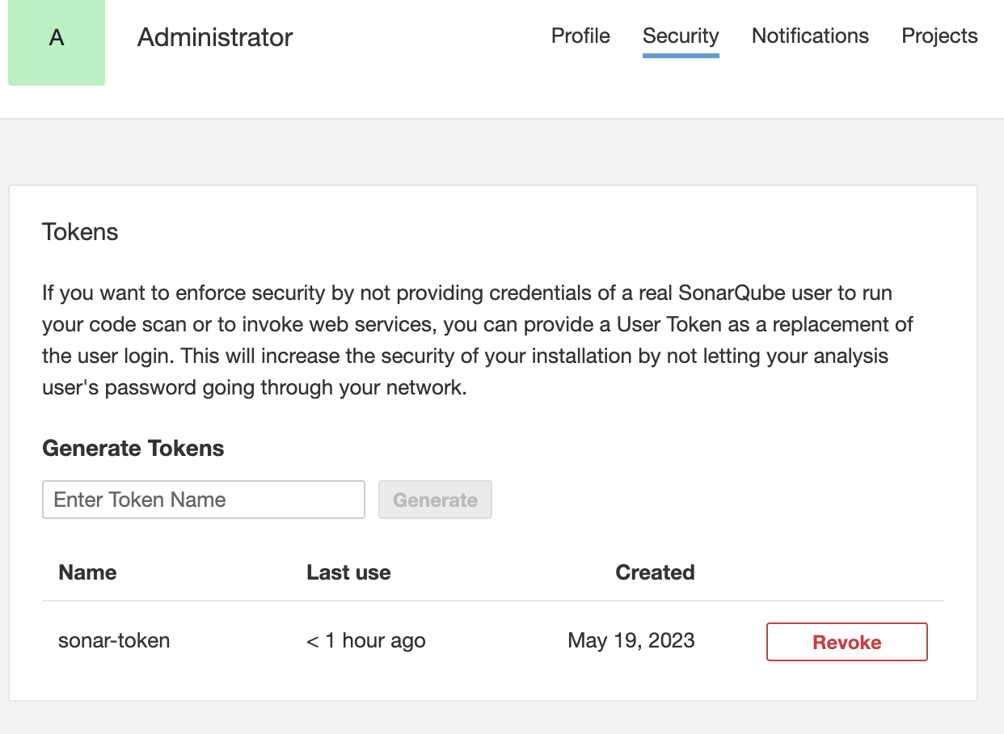

1. Install the plugin sonarqube in Jenkins server

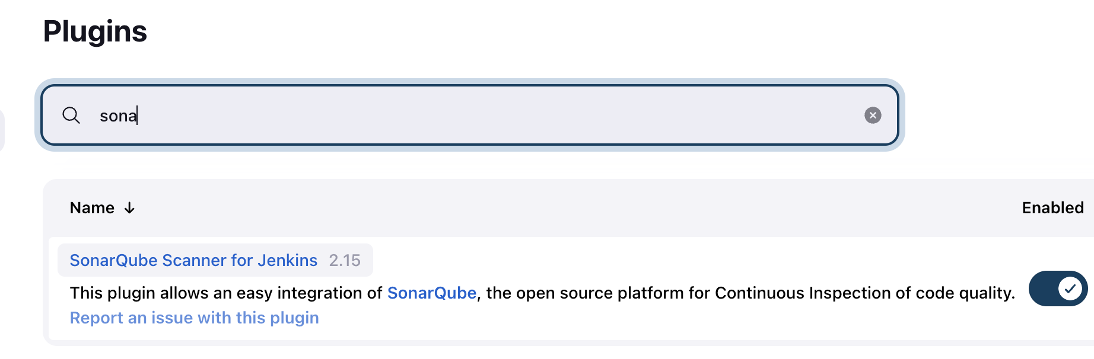

1. Add the sonar server in Jenkins configuration and add the token generated using secret text option

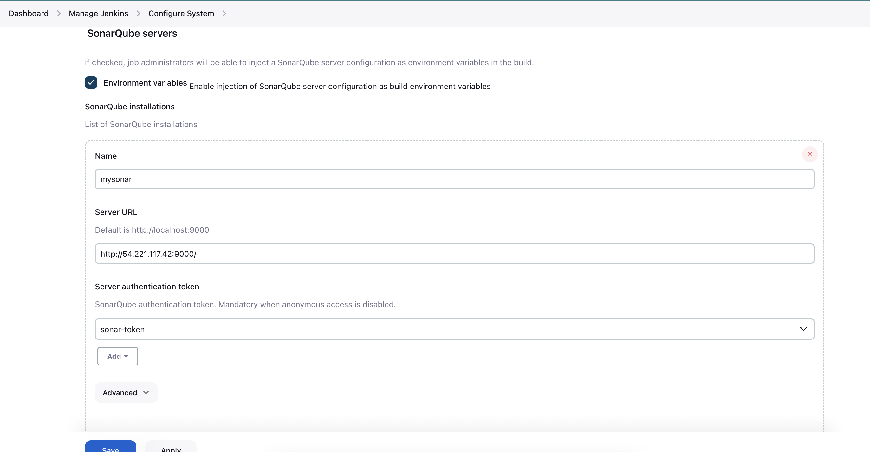

1. Inside the job configuration do the following changes and add mvn sonar:sonar to the execute shell

